IELTS Academic Writing Part One process tasks Error correction and discussion Work together to correct all the errors in the text below.

The flow chart illustrate the method by which the weather service in Australia puts together the latest datas on changes in the weather so that they can make accurate predictions. This essay will first describe the gathering of the data and finally how it is disseminated.

Information collected by three kinds of technology: satellites in space, radar posts on the ground, buoys floating in the sea. All three go towards creating charts with lines representing the whether. Radar and satellite images are also produced. These are then bringed together in one computer.

From computer, information on the weather is transmitted to three different places so that people can find out what they need to. In addition the obvious sources of TV weather forecasts on the news and information at the radio, the Australian Bureau of Meteorology also produces a recorded announcement that can accessed by telephone.

(Task from Cambridge IELTS 1, page 51)

The diagram below shows how the Australian Bureau of Meteorology collects up-to-the-minute information on the weather in order to produce reliable forecasts.
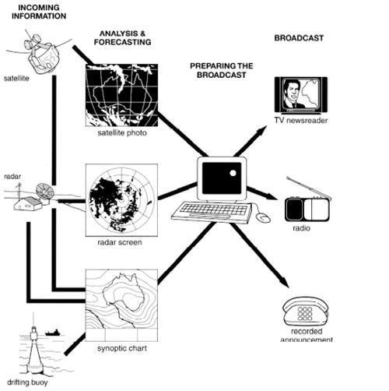

Hint 1: There is one error per line.

-----------------------------------------------------------------

Hint 2: The errors are in bold below.

The flow chart illustrate the method by which the weather service in Australia puts together the latest datas on changes in the weather so that they can make accurate predictions. This essay will first describe the gathering of the data and finally how it is disseminated.

Information collected by three kinds of technology: satellites in space, radar posts on the ground, buoys floating in the sea. All three go towards creating charts with lines representing the whether. Radar and satellite images are also produced. These are then bringed together in one computer.

From computer, information on the weather is transmitted to three different places so that people can find out what they need to. In addition the obvious sources of TV weather forecasts on the news and information at the radio, the Australian Bureau of Meteorology also produces a recorded announcement that can accessed by telephone.

---------------------------------------

Suggested answer

The flow chart illustrates the method by which the weather service in Australia puts together the latest data on changes in the weather so that they can make accurate predictions. This essay will first describe the gathering of the data and then how it is disseminated.

Information is collected by three kinds of technology: satellites in space, radar posts on the ground, and buoys floating in the sea. All three go towards creating charts with lines representing the weather. Radar and satellite images are also produced. These are then brought together in one computer.

From the computer, information on the weather is transmitted to three different places so that people can find out what they need to. In addition to the obvious sources of TV weather forecasts on the news and information on the radio, the Australian Bureau of Meteorology also produces a recorded announcement that can be accessed by telephone.

Analysis/ Discussion
- What is good about the suggested answer above?
- What could still be improved?
- How is the answer similar to other IELTS Academic Writing Part One tasks (line graph, bar chart, pie chart, table, map)?
- How is it different?

Try to find examples of the things below and tick in the left hand column for things which are included. Not all are included in this answer.

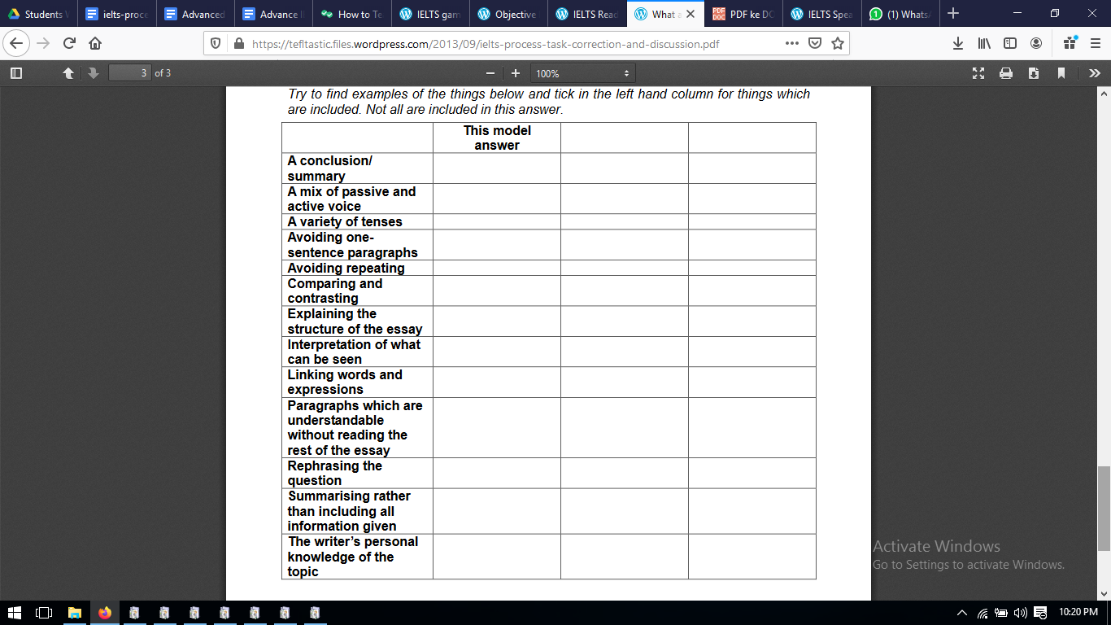

What things above should be included in different kinds of tasks?
Which Should never be included in IELTS Academic Writing Part One answers?
Label the other two columns “Other Part One tasks” and “Never in Writing Part One” and tick in those columns!

